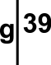

Wyndham Arcade
Mill Lane, Cardiff
CF10 1FH
+44 (0) 29 2025 5541
www.g39.org

Open: Wed – Sat 11-5.30pm
to 24 July 2010

Candice Jacobs is one of the Founding Directors of Moot, an artist-led gallery space in Nottingham. Jacobs is also a member of Stand Assembly, and Artist studio collective based in Nottingham.

Coming soon in the If…season:
Dawn Woolley
28 July – 14 August

If….

Candice Jacobs 07- 24 July

Nottingham based Artist Candice Jacobs continues g39's If.... season. Jacobs works with a variety of media producing sound, video, painting and sculpture, with the intention of undermining the traditional role of the artist as retaining control and authorship over their work. Jacobs engages in what could be described as transactional work that involves the exchange of ideas and constructs with social groups or objects that become attached or connected to her through her many roles in daily life.

This involves an intentional near collapse of narrative as she pulls away the structure that supports it. This is apparent in the new sound piece ‘Work’ in which Jacobs recorded interviews with waiters and waitresses to discover their feelings about the balance between employment and contentment. After the recordings Jacobs cut and kept cutting until the dialogue collapsed to leave only the words ‘work’ and ‘happiness’. This cyclical soundtrack now emanates from two speakers that are so placed as to make you enter into the middle of a conversation where you are left to decide the balance of work and happiness to these disembodied voices.

Accompanying this is a screen-based piece called ‘Situation Shot’ which uses the linking shots from various well-known American sitcoms. Traditionally these shots are just to establish the transition from one location to another in the narrative. They create an illusion of geographical reality as we merely move from one studio set to another. They are usually accompanied by a sound bite of music to indicate a change of pace or mood that prepares us for the continuation of the narrative that follows. As before, Jacobs has removed the preceding and following dialogue and the sound bite of music to leave us with no connection nor indication of where we have come from and where we are going. The exteriors are mute and forever closed to us as we stand outside waiting for something to happen.

On the floor is the sculpture ‘The London Paper’, an acrylic cast of a free paper that has been sprayed gold. Like ‘Situation Shot’ the original paper has false links between even falser ‘news’ items. This paper is based on gossip and conjecture rather than reality. Jacobs has preserved the paper in the same folded state it was discovered in. The process of casting and spraying removes the identifiers of mass produced narrative and reduces it to potential reporting rather than actual. We are left to transform the balance of news and gossip for ourselves.

The final piece in the show comes from a new series entitled ‘Studio Paintings’. Jacobs takes a photograph of her studio whenever she visits it and then sends the image to painters who remain unidentified to interpret as they see fit with the only restriction being that their response isn’t photorealistic. There is no communication after that point and the resulting painting is then sent back to Jacobs. The relinquishing of control over the final outcome in these paintings is in counterpoint to the other works where that control has been removed from the originator.

In all of the work the reduction of narrative to the point of collapse leaves us with a freedom and that the original structures didn’t have. We can build our own narratives upon this simplicity or we can accept them for what they are and relax our desire to fill in the spaces and gaps.

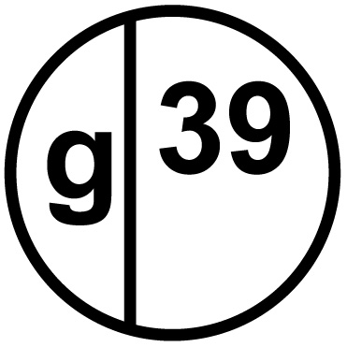

Company reg no 3938363

